Experiment 9

Title:
UI Testing using UIAutomator

Objective:
The objective of the experiment is to explore and understand UI testing using UI Automator, a testing framework provided by Android for testing the user interface of Android applications. The experiment aims to investigate how different features are supported by the UIAutomator framework.

Theory:-

1. Add UIAutomator library dependency:

In order to utilize the UIAutomator framework for UI testing, it is necessary to include the UI Automator library dependency in the Android project. This can be achieved by adding the appropriate dependency.

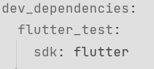

2. Create a UIAutomator test:

UI Automator tests are typically written in Java or Kotlin and are separate from the application codebase. These tests interact with the UI elements of the application just like a user would, enabling comprehensive testing of the application's UI behavior.
Tests are created within a separate test package or directory within the Android project structure.

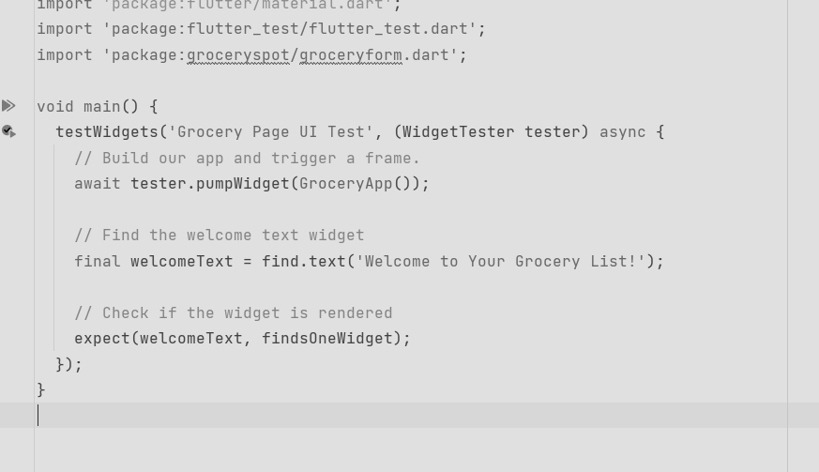

3. Write the test case:

Each UIAutomator test case is designed to perform a specific action or sequence of actions on the application's UI and verify the expected outcomes.
Test cases typically involve interactions with UI elements such as buttons, text fields, dialogs, etc., and assertions to validate the expected behavior of the application.
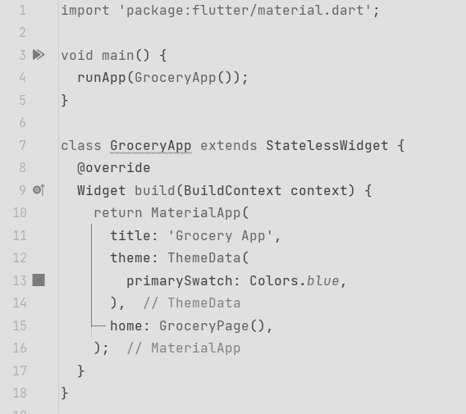
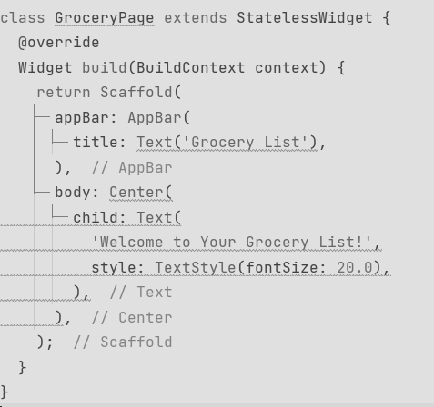

4. Run the test:

Once the UIAutomator test cases are written, they can be executed on a connected Android device or emulator.
Test execution can be initiated from the command line or using integrated development environments (IDEs) such as Android Studio.
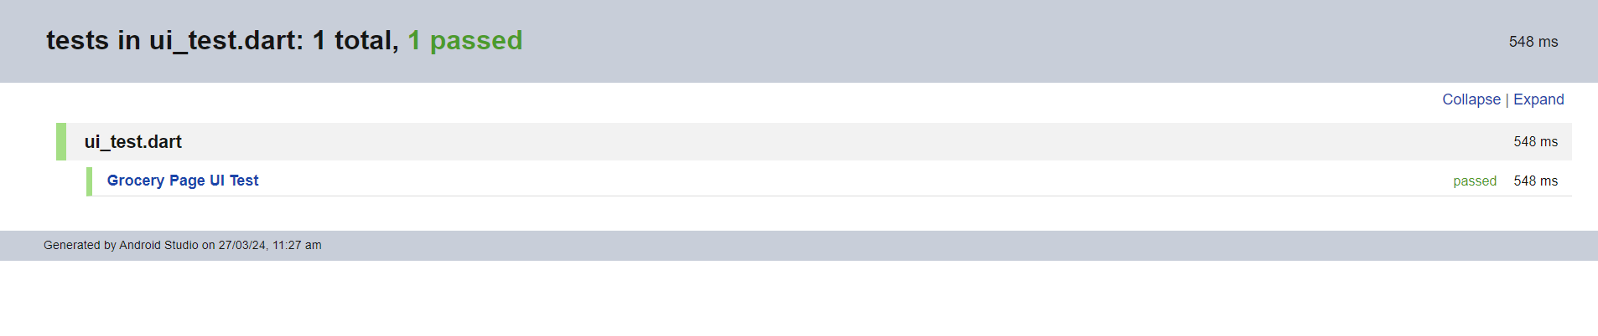

Conclusion:

The experiment provides insights into UI testing using the UI Automator framework, allowing testers to verify the behavior of Android applications across various devices and screen sizes. By understanding the capabilities of UI Automator and writing comprehensive test cases, developers can ensure the reliability and consistency of their application's user interface.

